Test Strategy Document
Revision 2.0
Last Print Date: 11/8/2026 - 11/8/2026

MyTax

Primary Author(s): Francisco Aguirre

Key Contributors: Francisco Aguirre
Gustavo Montes
Jose Carlos Martinez
Jorge Origel
Benjamin Villegas

Approvals: Template Version – 0.1

Role | Signature | Date
Software Engineering Manager | Benjamin Villegas
Validation Lead | Jose Carlos Martinez

Revision History

Version | Date | Author’s Full Name | Reason for Changes
1.0 | 01-oct-13 | Francisco Aguirre  Gustavo Montes  Jose Carlos Martinez  Jorge Origel  Benjamin Villegas | Initial Version
1.0 | 07-Nov-13 | Francisco Aguirre  Gustavo Montes  Jose Carlos Martinez  Jorge Origel  Benjamin Villegas | Corrections during V1 review

Abstract

My Taxes System will calculate the amount of taxes to be paid during a fiscal year by the users. The system will calculate the amount of money that the user can get in return because of the deductions during the year. User will have a list of recommendations that can help for getting more deductions. The application will be run in Android OS. The Testing Strategy (TS) is automate the test for the function that calculates the taxable amount, total taxes and the amount to paid or get in return in a fiscal year. The usability will be tested manually. We are going to do Unit Testing, Integration Testing, End-to-End Testing, Performance/Load Testing and User Acceptance Testing.

Table of Contents

1 Introduction 1
1.1 Purpose and Scope of this Document 1
1.2 Definitions 1
1.3 Team 1
1.4 Related Documents 1
1.5 Test Deliverables 1
1.6 Roles and Responsibilities 2
2 Test Scope 2
2.1 Product Requirements 2
2.1.1 Android Platform Development 2
2.1.2 Deductions, Incomes and Withholdings 2
2.1.3 Tax Calculation 2
2.1.4 SAT Regulations 3
2.1.5 User Interfaces 3
2.1.6 Performance Requirements 3
2.1.7 Security Requirements 3
2.1.8 Software Quality Attributes 4
2.2 Use Cases 4
2.3 Configuration Matrix 6
3 Test Approaches 7
3.1 Test Cases 7
3.2 Test Tools 16
3.3 Risk Management 16
3.4 Defect Management 17
3.5 Logistics 17

Introduction

Purpose and Scope of this Document

The purpose of this document is to provide the test strategy for the requirements of MyTax application.

Definitions

Term | Definition
SRS | Software Requirements Specification
TS | Test Strategy
UAT | User Acceptance Testing
UT | Unit Test
UC | Use Case

Team

Member of Quality Team:
- Benjamin Villegas
- Francisco Aguirre

Related Documents

Author | Version | Title | Location
Benjamin Villegas | 1.0 | MyTax SRS | https://github.com/faguirre154/MyTax.git
Benjamin Villegas | 1.0 | MyTax Vision and Scope | https://github.com/faguirre154/MyTax.git
Benjamin Vilelgas | 1,0 | MyTax - Master Test Plan.xls | https://github.com/faguirre154/MyTax.git

Test Deliverables

All test cases defined in Section 3.1 will be scheduled. Output will be saved in the Test Plan for MyTax project and it will be checked in GitHub.

Roles and Responsibilities

Project Manager: Benjamin Villegas
Test cases designer: MyTax team
Test cases reviewer: MyTax team
Developer1: José Carlos Martínez
Developer2: Gustavo Montes
Developer3: Jorge Origel
Developer4: Benjamin Villegas

Test Scope

Product Requirements

Android Platform Development
REQ- 3.1.2.2: System shall be able to connect to a remote database to update the actual SAT regulations

Deductions, Incomes and Withholdings
REQ- 3.2.2.1: System shall allow user store, delete and edit income monthly salary and number of months that apply.
REQ- 3.2.2.2: System shall allow user store, delete and edit withholdings for the monthly salary and number of months that apply.
REQ- 3.2.2.3: System shall allow user store, delete and edit other monthly incomes that are part of the taxable annual amount.

REQ- 3.2.2.4: System shall allow user to store, delete and edit expenses for available deductions from the SAT regulation during the fiscal year.

Tax Calculation
REQ-3.3.2.1: System shall calculate total annual income. This is the sum from all the incomes (multiplied for the times that apply) entered by user for a fiscal year.

REQ-3.3.2.2: System shall calculate total deductions; sum of deductions per year based on the actual SAT deduction rules for a fiscal year.

REQ-3.3.2.3: System shall calculate the total withholdings during the fiscal year.

REQ-3.3.2.4: System shall calculate ISR TAX over the annual taxable amount (this is the total income minus the deductions) using SAT regulation table rates.

REQ-3.3.2.5: System shall calculate Return or Debt using the ISR TAX calculated minus the withholdings.

REQ-3.3.2.6: System shall provide guidance to manage deductible expenses, based on the actual SAT regulations.

SAT Regulations
REQ-3.4.2.1: Remote Server store actual SAT regulations by Fiscal Year. It is updated manually by MyTax team.

REQ-3.4.2.2: Remote Server store actual SAT regulations in a SQLITE database.

User Interfaces
REQ 4.1.1: Account setup page.

REQ 4.1.2: Page with SAT regulation guide for a fiscal Year.

REQ 4.1.3: Page to enter deductions.

REQ 4.1.4: Page to enter withholding.

REQ 4.1.5: Page to enter incomes.

REQ 4.1.6: Page to calculate ISR Taxes with deductions.

REQ 4.1.7: Page to calculate ISR Taxes without deductions.

Performance Requirements
REQ 5.1.1: Response time for calculating taxes should be no more than 2 minutes.

Security Requirements
REQ 5.2.1: The user will have the option to enable a 4 numeric digit password, by default the application won’t have this option enabled.

Software Quality Attributes
REQ 5.3.1: The application should work with and without Internet connection.

Use Cases

- Incomes, Deductions and Withholdings:
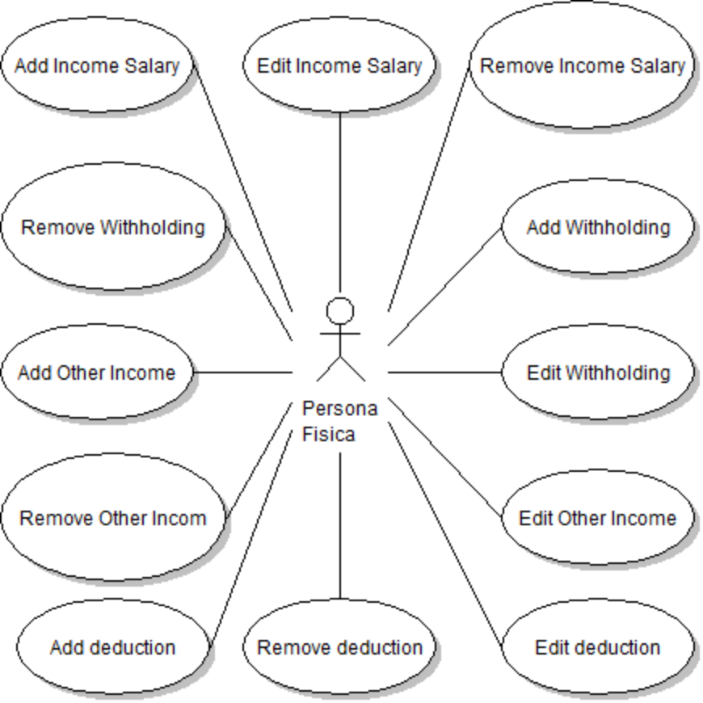

- Sat Regulations Guidance



- Calculations

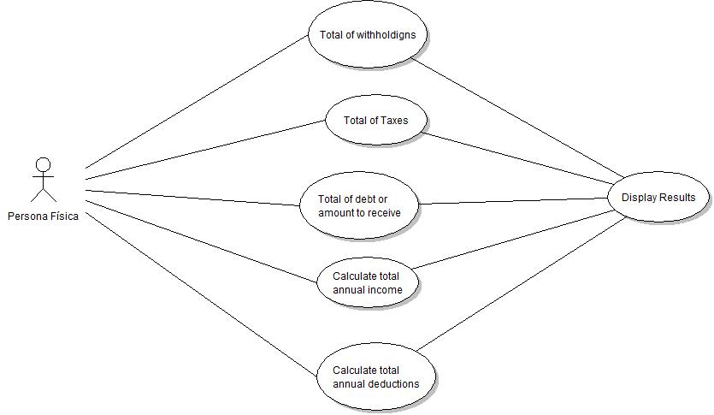

- Settings

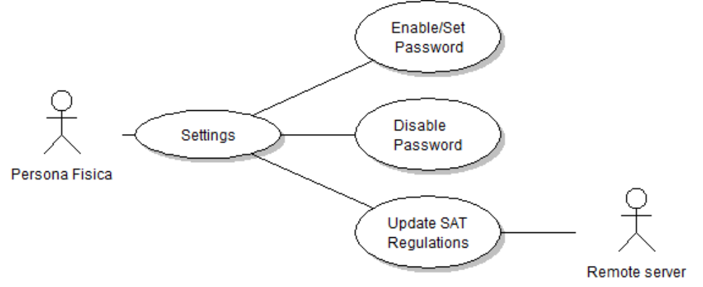

Configuration Matrix

Device Configuration | HW | SW
PC – Development environment | Laptop Latitude E6410 | Windows 7, Eclipse, Android SDK 4.0 +, Java SDK 1.7, Git, SQLite
PC – Server | Laptop Latitude E6410 | SQLite, Jenkins
Mobile device | Motorola RAZR-I Intel inside | Android 4.2

Test Approaches

Test Cases

We use a Master Plan to execute the Manual Testing. Bellow the Unit Test Cases used as base for the other testing Cycles documented on Master Template document: MyTax - Master Test Plan.xls

Test Case ID | Target Requirement ID | Priority | Test Case Name | Test Case Description | Pre Conditions | Expected Results
UT_001 | REQ 4.1.4 | P1 | Income Navigation | 1. Click 'Incomes' button  2. Click 'Add' button | User logged into the system | Add Income window active
UT_002 | REQ 4.1.4 | P1 | Income Summary Navigation | 1. Click 'Incomes' button | User logged into the system | Income Summary window active
UT_003 | REQ 4.1.5 | P1 | Withholding Navigation | 1. Click 'Incomes' button  2. Click 'Add' button | User logged into the system | Add Withhold window active
UT_004 | REQ 4.1.5 | P1 | Withholding Summary Navigation | 1. Click 'Incomes' button | User logged into the system | Withhold Summary window active
UT_005 | REQ. 3.2.2.1 | P1 | Adding Monthly incomes salary | 1. Select 'Salary' from the Income Type  2. Enter a value of 10000  3. Select from the date JAN-2013  4. Select 'Period' 12  5. Enter Comments 'My Salary'  6. Click 'Save' | UT_001 complete. | Income saved on the application and showing on the income summary
UT_006 | REQ. 3.2.2.1 | P1 | Adding Monthly incomes salary | 1. Select 'Salary' from the Income Type  2. Enter a value of 10000  3. Select from the date JAN-2013  4. Select 'Period' 12  5. Enter Comments 'My Salary'  6. Click 'Cancel' | UT_001 complete. | Income not saved on the application and not showing on the income summary
UT_007 | REQ. 3.2.2.1 | P1 | Adding Monthly incomes salary | 1. Select 'Salary' from the Income Type  2. Enter a value of -1  3. Select from the date JAN-2013  4. Select 'Period' 12  5. Enter Comments 'My Salary'  6. Click 'Save' | UT_001 complete. | Income not saved, application should fire a message 'Salary income cannot be lower than 0'
UT_008 | REQ. 3.2.2.1 | P1 | Adding Monthly incomes salary | 1. Select 'Salary' from the Income Type  2. Enter a value of 10000  3. Select from the date FEB-2013  4. Select 'Period' 12  5. Enter Comments 'My Salary'  6. Click 'Save' | UT_001 complete. | Income not saved, application should fire a message 'Period is beyond this Fiscal Year'
UT_009 | REQ. 3.2.2.1 | P1 | Adding Monthly incomes salary | 1. Select 'Salary' from the Income Type  2. Enter a value of 10000  3. Select from the date JUL-2013  4. Select 'Period' 6  5. Enter Comments 'My Salary'  6. Click 'Save' | UT_001 complete.  A salary income with date of JAN-2013 and Period of 6 stored on the application. | Income saved on the application and showing on the income summary
UT_010 | REQ. 3.2.2.1 | P1 | Adding Monthly incomes salary | 1. Select 'Salary' from the Income Type  2. Enter a value of 10000  3. Select from the date MAY-2013  4. Select 'Period' 6  5. Enter Comments 'My Salary'  6. Click 'Save' | UT_001 complete.  A salary income with date of JAN-2013 and Period of 6 stored on the application. | Income not saved, application should fire a message 'Salary Income Periods cannot overlap'
UT_011 | REQ. 3.2.2.1 | P1 | Removing Monthly incomes salary | 1. Select Income  2. Click 'Delete' | UT_001 complete.  A salary income with date of JAN-2013 and Period of 6 stored on the application. | Income removed, application not showing on the income summary
UT_012 | REQ. 3.2.2.1 | P1 | Removing Monthly incomes salary | 1. Don't select anything  2. Click 'Delete' | UT_001 complete.  A salary income with date of JAN-2013 and Period of 6 stored on the application. | Application fires message 'Please select an income'
UT_013 | REQ. 3.2.2.1 | P1 | Editing Monthly income salary | 1. Select Income  2. Click 'Edit' | UT_001 complete.  A salary income with date of JAN-2013 and Period of 6 stored on the application. | Add Income window active showing all the values for the income
UT_014 | REQ. 3.2.2.1 | P1 | Editing Monthly income salary | 1. Don't select anything  2. Click 'Edit' | UT_001 complete.  A salary income with date of JAN-2013 and Period of 6 stored on the application. | Application fires message 'Please select an income'
UT_015 | REQ. 3.2.2.2 | P1 | Adding Monthly withholding | 1. Select any withholding from the Withhold Type  2. Enter a value of 10000  3. Select from the date JAN-2013  4. Select 'Period' 12  5. Enter Comments 'My Withholding'  6. Click 'Save' | UT_003 complete. | Withhold saved on the application and showing on the withhold summary
UT_016 | REQ. 3.2.2.2 | P1 | Adding Monthly withholding | 1. Select any withholding from the Withhold Type  2. Enter a value of 10000  3. Select from the date JAN-2013  4. Select 'Period' 12  5. Enter Comments 'My Withholding'  6. Click 'Cancel' | UT_003 complete. | Withhold not saved on the application and not showing on the withhold summary
UT_017 | REQ. 3.2.2.2 | P1 | Adding Monthly withholding | 1. Select any withholding from the Withhold Type  2. Enter a value of -1  3. Select from the date JAN-2013  4. Select 'Period' 12  5. Enter Comments 'My Withholding'  6. Click 'Save' | UT_003 complete. | Withhold not saved, application should fire a message 'Withhold cannot be lower than 0'
UT_018 | REQ. 3.2.2.2 | P1 | Adding Monthly withholding | 1. Select any withholding from the Withhold Type  2. Enter a value of 10000  3. Select from the date FEB-2013  4. Select 'Period' 12  5. Enter Comments 'My Withholding'  6. Click 'Save' | UT_003 complete. | Witthold not saved, application should fire a message 'Period is beyon this Fiscal Year'
UT_019 | REQ. 3.2.2.2 | P1 | Adding Monthly withholding | 1. Select any withholding from the Withhold Type  2. Enter a value of 10000  3. Select from the date JUL-2013  4. Select 'Period' 6  5. Enter Comments 'My Withholding'  6. Click 'Save' | UT_003 complete.  A withhold with date of JAN-2013 and Period of 6 stored on the application. | Withhold saved on the application and showing on the withhold summary
UT_020 | REQ. 3.2.2.2 | P1 | Adding Monthly withholding | 1. Select any withholding from the Withhold Type  2. Enter a value of 10000  3. Select from the date MAY-2013  4. Select 'Period' 6  5. Enver Comments 'My Withholding'  6. Click 'Save' | UT_003 complete.  A withhold with date of JAN-2013 and Period of 6 stored on the application. | Withhold not saved, application should fire a message 'Withholding Periods cannot overlap'
UT_021 | REQ. 3.2.2.2 | P1 | Adding Monthly withholding | 1. Select Withhold  2. Click 'Delete' | UT_003 complete.  A withhold with date of JAN-2013 and Period of 6 stored on the application. | Withhold removed, application not showing on the withhold summary
UT_022 | REQ. 3.2.2.2 | P1 | Adding Monthly withholding | 1. Don't select anything  2. Click 'Delete' | UT_003 complete.  A withhold with date of JAN-2013 and Period of 6 stored on the application. | Application fires message 'Please select a withhold'
UT_023 | REQ. 3.2.2.2 | P1 | Adding Monthly withholding | 1. Select Withhold  2. Click 'Edit' | UT_003 complete.  A withhold with date of JAN-2013 and Period of 6 stored on the application. | Add Withhold window active showing all the values for the withhold
UT_024 | REQ. 3.2.2.2 | P1 | Adding Monthly withholding | 1. Don't select anything  2. Click 'Edit' | UT_003 complete.  A withhold with date of JAN-2013 and Period of 6 stored on the application. | Application fires message 'Please select an withhold'
UT_025 | REQ. 3.2.2.3 | P1 | Adding Other Monthly incomes salary | 1. Select 'Bonus' from the Income Type  2. Enter a value of 10000  3. Select from the date JAN-2013  4. Select 'Period' 12  5. Enter Comments 'My Salary'  6. Click 'Save' | UT_001 complete. | Income saved on the application and showing on the income summary
UT_026 | REQ. 3.2.2.3 | P1 | Adding Other Monthly incomes salary | 1. Select 'Bonus' from the Income Type  2. Enter a value of 10000  3. Select from the date JAN-2013  4. Select 'Period' 12  5. Enter Comments 'My Salary'  6. Click 'Cancel' | UT_001 complete. | Income not saved on the application and not showing on the income summary
UT_027 | REQ. 3.2.2.3 | P1 | Adding Other Monthly incomes salary | 1. Select 'Bonus' from the Income Type  2. Enter a value of -1  3. Select from the date JAN-2013  4. Select 'Period' 12  5. Enter Comments 'My Salary'  6. Click 'Save' | UT_001 complete. | Income not saved, application should fire a message 'Salary income cannot be lower than 0'
UT_028 | REQ. 3.2.2.3 | P1 | Adding Other Monthly incomes salary | 1. Select 'Bonus' from the Income Type  2. Enter a value of 10000  3. Select from the date FEB-2013  4. Select 'Period' 12  5. Enter Comments 'My Salary'  6. Click 'Save' | UT_001 complete. | Income not saved, application should fire a message 'Period is beyon this Fiscal Year'
UT_029 | REQ. 3.2.2.3 | P1 | Adding Other Monthly incomes salary | 1. Select 'Bonus' from the Income Type  2. Enter a value of 10000  3. Select from the date JUL-2013  4. Select 'Period' 6  5. Enter Comments 'My Salary'  6. Click 'Save' | UT_001 complete.  A salary income with date of JAN-2013 and Period of 6 stored on the application. | Income saved on the application and showing on the income summary
UT_030 | REQ. 3.2.2.3 | P1 | Adding Other Monthly incomes salary | 1. Select 'Bonus' from the Income Type  2. Enter a value of 10000  3. Select from the date MAY-2013  4. Select 'Period' 6  5. Enter Comments 'My Salary'  6. Click 'Save' | UT_001complete.  A salary income with date of JAN-2013 and Period of 6 stored on the application. | Income not saved, application should fire a message 'Salary Income Periods cannot overlap'
UT_031 | REQ. 3.2.2.3 | P1 | Removing Other Monthly incomes salary | 1. Select Income  2. Click 'Delete' | UT_001 complete.  A salary income with date of JAN-2013 and Period of 6 stored on the application. | Income removed, application not showing on the income summary
UT_032 | REQ. 3.2.2.3 | P1 | Removing Other Monthly incomes salary | 1. Don't select anything  2. Click 'Delete' | UT_001 complete.  A salary income with date of JAN-2013 and Period of 6 stored on the application. | Application fires message 'Please select an income'
UT_033 | REQ. 3.2.2.3 | P1 | Editing Other Monthly income salary | 1. Select Income  2. Click 'Edit' | UT_001 complete.  A salary income with date of JAN-2013 and Period of 6 stored on the application. | Add Income window active showing all the values for the income
UT_034 | REQ. 3.2.2.3 | P1 | Editing Other Monthly income salary | 1. Don't select anything  2. Click 'Edit' | UT_001 complete.  A salary income with date of JAN-2013 and Period of 6 stored on the application. | Application fires message 'Please select an income'
UT_035 | REQ 3.2.2.4  REQ 4.1.3 | P1 | Save Deductions. | 1.- Select Fiscal Year  2.- Click on deductions button.  3.- Click Add new deduction  4.- Select deduction Type  5.- Entry all fields related to this deduction  6.- Click Add Button.... | - User is already in the main screen | The deduction should be correctly inserted into local database such as :  - Medical Fees  - Major Medial Insurance  - mortgage credit  - School Fees
UT_036 | REQ 3.2.2.4  REQ 4.1.3 | P1 | Save Deductions Negative value | 1.- Select Fiscal Year  2.- Click on deductions button.  3.- Click Add new deductions  4.- Select deductions Type  5.- Entry a negative deduction value  6.- Click Add Button.... | - User is already in the main screen | An error message should show up alerting that user cannot introduce a negative deduction value value
UT_037 | REQ 3.2.2.4  REQ 4.1.3 | P1 | Remove Deductions | 1.- Select Fiscal Year  2.- Click on deductions button.  3.- Select a deduction to remove  4.- Click on Remove button | - User is already in the main screen | The deduction selected should be removed
UT_038 | REQ 3.2.2.4  REQ 4.1.3 | P1 | Cancel Deductions | 1.- Select Fiscal Year  2.- Click on deductions button.  3.- Click Add new deduction  4.- Select deduction Type  5.- Entry all fields related to this deduction.  6.- Click Cancel Button.... | - User is already logged into the application in the main screen | Record entered is not saved.
UT_039 | REQ 3.2.2.4  REQ 4.1.3 | P1 | Edit Deductions | 1.- Select Fiscal Year  2.- Click on deductions button.  3.- Select a deduction expense to edit  4.- Click on Edit button  5.- Entry all fields to update related to this deduction.  6.- Click on save Button.... | - User is already in the main screen | The expense to be updated should have saved the new values.
UT_040 | REQ 3.3.2.1  REQ 4.1.7 | P1 | Calculate Total annual income without deductions | 1.- Select Fiscal Year  2.- Click 'Calculate Taxes without deductions' button  3.- Look at the Income field and see if it contains the right value | - User is already in the main screen  - All possible user salaries, and other Earnings, based on SAT regulations, should be already stored into local database to be able to provide the output of calculations, | The calculations should done and displayed to let the user know about the total income along of the fiscal year and based on the amount.
UT_041 | REQ 3.3.2.1  REQ 4.1.6 | P1 | Calculate Total annual income with deductions | 1.- Select Fiscal Year  2.- Click 'Calculate Taxes with deductions' button  3.- Look at the Income field and see if it contains the right value | - User is already in the main screen  - All possible user salaries, and other Earnings, based on SAT regulations, should be already stored into local database to be able to provide the output of calculations, | The calculations should done and displayed to let the user know about the total income along of the fiscal year and based on the amount.
UT_042 | REQ-3.3.2.2 | P1 | Calculate total anual deductions | 1.- Select Fiscal Year  2.- Click 'Calculate Taxes with deductions' button  3.- Look at the deductions field and see if it contains the right value | - User is already in the main screen  - All possible user deductions, based on SAT regulations, should be already stored into local database to be able to provide the output of calculations | The calculations should be done and displayed to let the user know about the total of deductions along of the fiscal year.
UT_043 | REQ-3.3.2.3 | P1 | Withholding Calculation  For any amount of incomes, the system must return the total amount of withholdings for the current fiscal year. | Calculation must be executed after pressing the button.  1. Select fiscal year  2. Click 'Calculate taxes with Deductions' button  2. Look at the withholding field and see if it contains the right value | Software must have implemented the rules needed to calculate the withholdings and the incomes must be registered in the application | Amount of money that needs to be paid according to the income registered.
UT_044 | REQ-3.3.2.4 | P1 | ISR over annual taxable amount. For any amount of incomes, the system must return the estimated amount of ISR Tax, calculating the total income minus the deductions for the current fiscal year | Calculation must be executed after pressing the button.  1. Press 'Calculate with Deductions' button  2. Review Tax amount | Software must have implemented the rules needed to calculate the withholdings and the incomes must be registered in the application | Amount of money that needs to be paid according to the income registered.
UT_045 | REQ-3.3.2.5 | P1 | Return or Debt. The application will show if the user has a debt with the government or if the user will receive any return for all the taxes paid during the fiscal year | Once the taxes are calculated with the rules from SAT, the application must show the amount to pay or receive.  1. Press 'Calculate with Deductions' button  2. Review total result | Software must have implemented the rules needed to calculate the withholdings and the incomes must be registered in the application | User needs to see the amount of returns or debt for the input done into the application.
UT_046 | REQ-3.3.2.6 | P1 | Guide for deductible expenses | The application will show a list of possible expenses that can be registered for increasing the deductions.  1. Press information button | Software must have the possible deductions rules in the device. | after pressing the button, a text box is going to appear with the information.
UT_047 | REQ- 3.1.2.2  REQ 4.1.1 | P1 | Update SAT Regulations from remote server | 1. Click Settings Icon (*)  2. Click Update Regulations button | New Regulation entered for 2014 | Updated Regulations. New available year to select
UT_048 | REQ- 3.1.2.2  REQ 4.1.1 | P1 | Update SAT Regulations from remote server | 1. Click Settings Icon (*)  2. Click Update Regulations button  3. Enter a new deduction for "Secundaria" for 14,000 | Updated regulation for "Secundatia" limit from 12,000 to 14,000 | System allow entered 14,000 for deductions
UT_049 | REQ-3.4.2.1  REQ-3.4.2.2 | P2 | Remote Server store actual SAT regulations by Fiscal Year. | In remote Server:  1. Open SQLite Database Browser 2.0 b1  2. Execute Query ….. | MyTax Team Updated the tables | Query returns Regulations stored in the database.
UT_050 | REQ 5.1.1 | P2 | Response time for calculating taxes should be no more than 2 minutes. | 1. Select a Fiscal Year  2. Navigate to Calculate Taxes Button | Display the Calculated Taxes and deductions for the fiscal year selected | Display the results in less than 2 minutes
UT_051 | REQ 5.2.1  REQ 4.1.1 | P3 | Enable Password | 1. Click Setting Button  2. Select enable Password  3. Type a 4 digits password  4. Close the application and clear it form memory  5. Open Application  6. Type your password selected on step 3 | UT-001 | Set the password. User will be asked for a password when open the application
UT_052 | REQ 5.2.1  REQ 4.1.1 | P3 | Disable Password | 1. Click Setting Button  2. Select Disable Password  3. Close the application and clear it form memory  4. Open Application  5. password will not asked |  | User will not be asked for a password when open the application.
UT_053 | REQ 5.3.1 | P2 | The application should work without Internet connection. | 1. Disable Internet  2. Open Application  3. Click Incomes button  4. Enter on row  5. Validate that is saved |  | Save a row with internet Disabled
UT_054 | REQ 5.3.1 | P2 | The application should work with Internet connection. | 1. Disable Internet  2. Open Application  3. Click Incomes button  4. Enter on row  5. Validate that is saved |  | Save a row with internet enabled

Test Automation

We are going to create custom program to validate the function that calculate the taxes.

Scenarios:
- Not fail if tables (with Incomes, deductions and withholdings) are empty
- Only Data on Table Incomes. Program must return values as bellow examples:
  - Incomes for 100,000 Expected Result taxes 24,000, Debt or Return = 24,000
  - Incomes for 500,000 Expected Result taxes 150,000, Debt or Return = 150,000
- Data on Table Incomes and Withholding. Program must return values as bellow examples:
  - Incomes for 100,000, Withholding for 20,000, Expected Result taxes 24,000, Debt or Return = -4,000
  - Incomes for 500,000, Withholding for 502,000, Expected Result taxes 150,000, Debt or Return = 2,000
- Data on Table Incomes, Withholding, Deductions. Program must return values as bellow examples:
  - Incomes for 100,000, Withholding for 20,000, Deductions for 15,000, Expected Result taxes 24,000, Debt or Return = 3,500
  - Incomes for 500,000, Withholding for 502,000, Deductions for 45,000, Expected Result taxes 150,000, Debt or Return = 24,000
- Data on Withholding and Deductions, But not data on Incomes. Program must return 0
  - Withholding for 20,000, Deductions for 15,000, Expected Result taxes 0, Debt or Return = 0
  - Withholding for 502,000, Deductions for 45,000, Expected Result taxes 0, Debt or Return = 0

Coverage Measurement

- We are testing all functional requirements.
- We are not using tools and the plan is cover all the line codes during the unit testing.

Risk Management

- Function to calculate taxes:
- Return wrong data
- Calculation time is more that 2 minutes
- Update SAT regulations from the Remote Server is not working

Defect Management

- Unit testing must be reported immediately and fix the issue in case if exists.
- End-to-end, Integration Performance and user acceptance testing results are updated once per week and presented in to the committee during the weekly meeting.

Logistics

- Unit Testing – 4 Laptops in the Developers Site
- Integration Testing – 1 Mobile Device and 1 Laptops in the Developers Site
- End-to-end, Performance and user acceptance testing – 1 Mobile Device

APPENDIX
Appendix A: Glossary
- Persona física: person with the capacity of contracting rights and liabilities under a salary schema.

- SAT: Secretaria de Administración Tributaria (Mexican Local Tax Authority)

- ISR: Impuesto sobre la renta (Income Tax)

- Tax: Financial charge or other levy imposed upon a taxpayer

- Tax deduction: a reduction in the gross amount on which a tax is calculated; reduces taxes by the percentage fixed for the taxpayer's income bracket.

- Withholding: government requirement for the payer of an item of income to withhold or deduct tax from the payment

